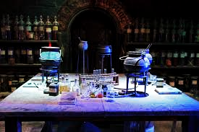

IDS 5142

Modeling and Simulation for Instructional Design

**Chemistry in the Wizarding World Simulation**

**Final Project**

July 31, 2019

**Prepared for:**

Dr. Barbara Truman

*University of Central Florida*

**Prepared by:**

Team Chemistry Wizards

University of Central Florida

**Courtney Berkley, Madeline Lopez, Meredith Ratliff**

# 0.0 Executive Summary

## 0.1 Introduction

**Chemistry and the Wizarding World**

Chemistry is a difficult subject for middle school aged students to learn. It is complex and abstract, so that learners are often left feeling as if there are no connections to their life or the real world. With new technologies coming to the forefront of education everyday, this simulation aims to solve this problem. Focusing on a specific unit in chemistry that teaches students about the pH scale and its relation to acids and bases, the goal is to create an engaging lesson that is set in a fictional world where wizards and magic exist. Students will be taking a “potions” class where they will be instructed by a silly wizarding instructor named Professor Hufflepot. Here they will learn about the pH scale, or Philosopher’s Herbology Scale, and how they can use it to create magical solutions to everyday “Wuggle” (non magic users) problems.

**Virtual Reality and Serious Games**

The foundation for this project will be created in Unity with a first person controller for game play. Unity allows for both interactive 3D games which could be played on almost any PC or as virtual reality (VR) for use with devices such as Google Cardboard (Unity, n.d.) which is an affordable option for VR in schools. The program can be hosted somewhere like Github for download onto a computer or mobile device for VR play.

**Benchmark examples:**

* Virtual World Lab Texas A&M:<https://www.youtube.com/watch?v=twAi73JCXOM>
* Acid/Base test (incorporated into the virtual world): <https://steamcommunity.com/app/716380>
* Virtual Reality, likely not feasible, but the ultimate design goal:<https://youtu.be/NSlkpNN5-4o>

Table of Contents

0.0 Executive Summary 1

0.1 Introduction 1

1.0 Needs Assessment 3

1.1 Information Sources and Types 3

1.2 Data Gathering Tools and Techniques 3

1.3 Needs Assessment Schedule 5

1.4 Results of Needs Assessment 6

2.0 Goal Analysis 6

2.1 Performance Goal 7

3.0 Cognitive Task (Skills) Analysis 7

4.0 Learner and Context Analysis 11

4.1 Learner Analysis 11

4.2 Context Analysis 11

5.0 Measurable Performance Outcomes 12

6.0 Instructional Treatment Plans 14

6.1 Game Concept 14

6.2 Game Play 14

7.0 Flowchart 15

8.0 Storyboard 15

9.0 Design and Delivery Standards 25

9.1 Functionality 25

9.2 Feasibility  25

9.3 Recommendations 26

10.0 Appendix 26

10.1 Appendix A - Assessments 26

10.2 Appendix B - Instruments 29

References 31

# 1.0 Needs Assessment

## 1.1 Information Sources and Types

In this section, a description of each source of information is provided. These sources will help maintain the focus of the project by providing insights and data needed. An overview of methods for collecting the information is also provided.

**Subject Matter Expert (SME)**

The SME that has agreed to provide insight into virtual and augmented reality is Kurt Scheuringer, AR/VR Software Lead, Adv. Vis. DT PI at Lockheed Martin. He will meet with the team to answer questions and provide guidance as to the possibilities of virtual simulations. As a professional in a similar field as to which the project is focused, Mr. Scheuringer will also be able to advise on the perspectives of businesses and protocols.

**Instructors**

As this project is focused on middle school aged children, any instructor input will provide valuable guidance to what the needs of teachers are, and how this type of lesson could be implemented in a classroom.

**Students**

Students are the eventual end users of the project, and as such their input will be sought after the project has reached its final stages. It is important for the resulting lesson to be engaging and educational in a clear and concise manner.

## 1.2 Data Gathering Tools and Techniques

The following tools and techniques will be utilized to gather information and collect data as it pertains to the Needs Assessment (NA) plan.

**Needs Analysis**

A needs analysis has been conducted to ensure that the focus of this project is going to be useful to schools, educators, and/or parents. The focus of the analysis will be gathering information from sources to ensure the usefulness of the lesson being taught and the direction of the project.

The poor performance of students in chemistry is often attributed to inadequate exposure to practical experience during instruction due to the hazards of some experiments or just lack of interest. A study conducted employing secondary chemistry students showed “that computer simulation had significant effect on students’ overall mean achievement in chemistry. The experimental group taught chemistry with computer simulation had higher mean achievement than the control group taught with lecture method” (Nkemakolam, Chinelo, & Jane 2018, p. 228).

**Cognitive Task Analysis**

A cognitive task analysis has been performed to determine what elements are critical and required for the success of the project. This information will provide insight into what the learner knows, how they perceive the lesson, and how they learn. A pre-test will be given to help determine readiness.

**Interviews and Formal Meetings**

Interviews will be conducted with teachers and students to gather information about needs and expectations. Formal meetings with the SME will be held to periodically ensure that the project is maintaining its correct course.

Table 1. NA Information Sources, Types, Tools, and Techniques

| Needs Assessment Plan | | | | | |
| --- | --- | --- | --- | --- | --- |
| SOURCES | TYPES   | Optimals | Actuals | Causes | Solutions | | --- | --- | --- | --- | | | | | Tools &  Techniques |
| SME | X |  |  | X | Subject Matter Analysis |
| Instructors | X | X | X | X | Interviews, focus groups, surveys, and Needs Analysis |
| Students |  | X | X | X | Interviews, focus groups, surveys, and Gap analysis |

## 1.3 Needs Assessment Schedule

The table below shows the projected timeline for the project and the person(s) responsible for that task’s completion.

Table 2. Needs Assessment Schedule

| **Task** | **Expected Duration** | **Due Date** | **Person Responsible** |
| --- | --- | --- | --- |
| Group Meeting to discuss basics | 1 hour | 5/30 | Group |
| Speak with SME (Kurt) | 1 hour | 6/3 | Group |
| Research platforms | 7 days | 6/7 | Meredith |
| Develop draft curriculum for virtual lab | 1 week | 6/9 | Madeline |
| **Draft Project plan due** |  | **6/9** | Group |
| Base Storyline script (narrative, characters, wording) | 5 days | 6/12 | Courtney |
| Group Meeting | 1 hour | 6/13 | group |
| Create the foundation on platform | 5 days | 6/14 | Meredith |
| Review cohesiveness of story/platform/objectives | 2 hours | 6/15 | Group |
| **Final Project plan due** |  | **6/16** | Group |
| Get feedback from SME | 1 hour | 6/17 | Group |
| Storyboard |  | 6/20 | Group |
| **DRAFT DESIGN DOCUMENT** | | | |
| -Needs Assessment | 2 weeks | 6/18 | Courtney |
| -Goal Analysis | 2 weeks | 6/11 | Madeline |
| -Cognitive Task Analysis (performance?) | 2 weeks | 6/18 | Madeline |
| -Learner and Context Analysis | 2 weeks | 6/18 | Meredith |
| -Measurable Performance Outcomes | 2 weeks | 6/17 | Madeline |
| -Instructional Treatment Plans | 2 weeks | 6/20 | Courtney |
| -Flowcharts and Storyboards | 2 weeks | 6/20 | Group |
| -Prototypes and Formative Assessments | 2 weeks | 6/20 | Meredith |
| -Design and Delivery Standards | 2 weeks | 6/20 | Group |
| -Design and Development Site | 2 weeks | 6/20 | Group |
| Group Meeting | 1 hour | 6/20 | Group |
| **Draft design document due** |  | **6/23** | Group |
| Group Meeting | 1 hour | 6/27 | Group |
| Build a prototype sequence | 2 weeks | 6/28 | Meredith |
| **Final design document due** |  | **7/7** | Group |
| Meet with SME | 1 hour | 7/1 | Group |
| Group Meeting | 1 hour | 7/4 | Group |
| Outside testing | 10 days | 7/8 | Group |
| Group Meeting | 1 hour | 7/11 | Group |
| Build all sequences | 2.5 weeks | 7/14 | Meredith/Group |
| Meet with SME | 1 hour | 7/15 | Group |
| Group Meeting | 1 hour | 7/18 | Group |
| Test with students | 5 days | 7/19 | Group |
| Group Meeting | 1 hour | 7/25 | Group |
| Meet with SME | 1 hour | 7/29 | Group |
| **Final project due** |  | **7/31** | Group |

## 1.4 Results of Needs Assessment

Currently, the primary challenge as it is understood to exist is the need for students to be engaged in difficult and abstract material. Educators have the knowledge that needs to be transferred to the learners for success in the course, however the long-term comprehension of the learners is lacking. Learners will briefly be able to answer questions on the subject but fail to remember the same material after several months.

# 2.0 Goal Analysis

Middle school aged learners will participate in an online simulation module to acquire and utilize knowledge and skills related to the properties of acids and bases. Terminal objectives for each module will provide support for subsequent modules (Figure 1).

Figure 1. Goal Analysis for Chemistry in the Wizarding World Acid/Base Module.

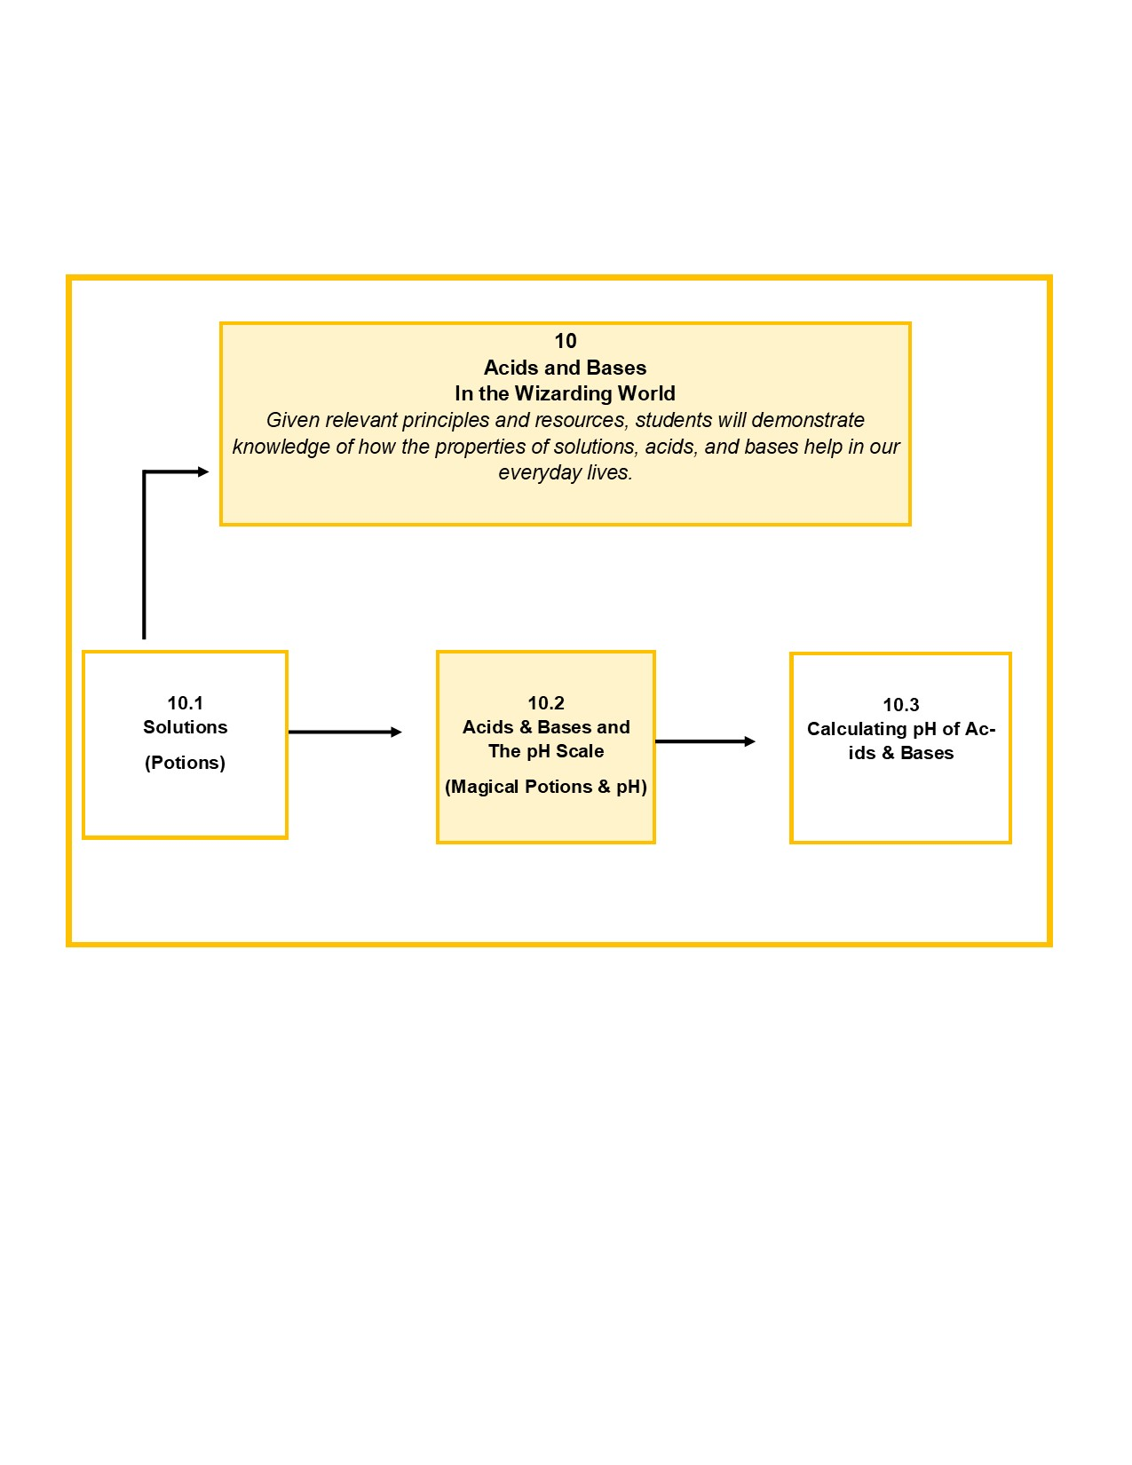

## 2.1 Performance Goal

Content limitations and parameters related to modeling and simulation for the performance goal/goal statement was determined based on recommendations and vetting by SME Kurt Scheuringer.

Goal Statement: *Given relevant principles and resources, students will demonstrate knowledge of how the properties of solutions, acids, and bases help in our everyday lives.*

# 3.0 Cognitive Task (Skills) Analysis

Although there are three sections to this lesson we will focus on 10.2.1 - Differentiate between acids and bases of different substances using an indicator. Figure 2, Subordinate Skill Analysis demonstrates a visual layout for the subordinate skills analysis associated with demonstrating knowledge of how the properties of solutions, acids, and bases help in our everyday lives.

As a result of participation in the simulation, learners will be able to identify and describe the properties of acids and bases and identify an acid and a base based on its properties. Note that the entry level skills for the learners require demonstration of necessary prerequisite knowledge from prior modules including awareness that an acid is a compound that contains H+ and increases the hydrogen ions (H+) present when dissolved in water and a base is a compound that contains OH- and increases the hydroxide ions (OH-) present when dissolved in water (Coolican, n.d.).

Figure 2. Subordinate Skills Analysis 10.2 Acids & Bases and the pH Scale (Magical Potions & pH). Compare and contrast the components and properties of acids and bases to determine acidity and basicity of common household substances using augmented/virtual environment.

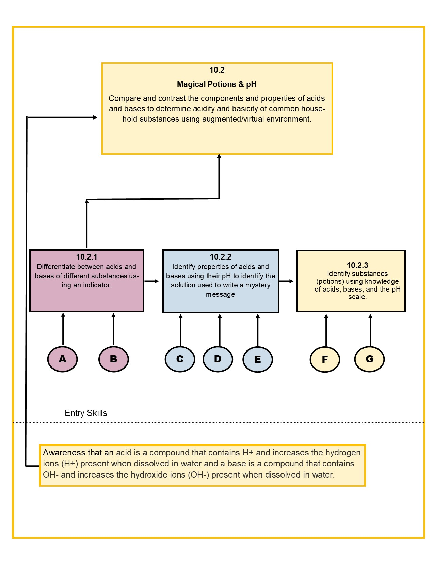

Figure 3. - Subordinate skills 10.2.1

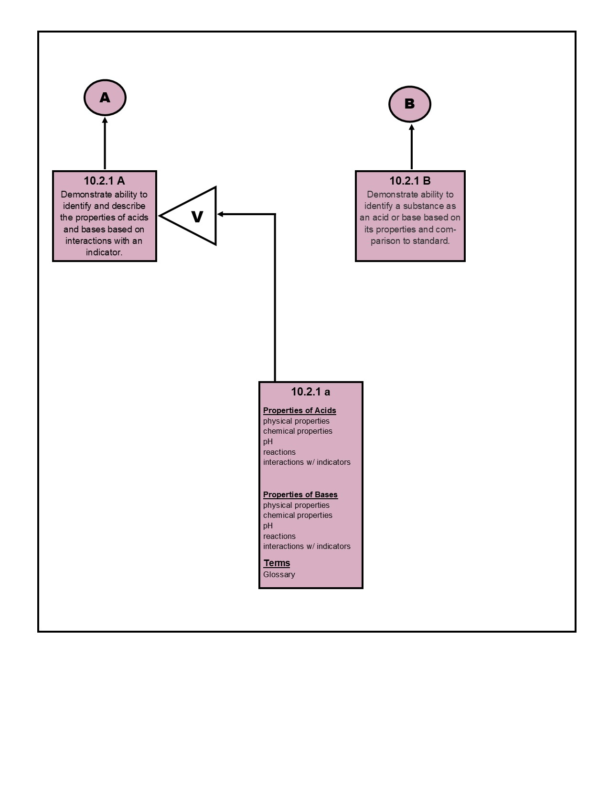

# 4.0 Learner and Context Analysis

## 4.1 Learner Analysis

**Prior Knowledge and Education**

Based on NGSS standards, middle school students will have the basic concepts of molecular structure, conservation of mass and simple chemical reactions. Students will also have an understanding of the scientific method (NGSS Lead States, 2013). This lab is intended to be used after the introduction of acids and bases. Prior to undertaking the lab, students will need to understand

* Solubility and ions
* Physical properties of acids and bases
* Acids increase the H+ ions and bases increase the OH- ions when dissolved in water

Students will be given a short pre-test to assess these requirements.

**Behavior and Attitude**  
As first coined by Prensky (2005), middle school students are “digital natives,” they have always known a world filled with technology. Digital natives think differently than generations past. They don’t want to be lectured; they want to create things, they embrace technology, and frequently, they enjoy the challenge of competition.

This new generation of digital natives are highly motivated by their passions and have the ability to concentrate on tasks they find appealing. With the Harry Potter franchise reaching the 500 million book mark worldwide in 2018 (Pottermore, 2018) and the fantasy genre being wildly popular among teens (NPR, 2012), the combination of technology and fantasy has the capacity to be highly engaging and motivational.

## 4.2 Context Analysis

**Physical Aspect of Site**

This lab will be an open resource, available for download as a 3D interactive game or virtual reality. It is expected that common use would be within school computer labs or classrooms equipped with laptops or desktops for student use. Students may also use mobile devices and Google Cardboard to access the VR version. Students will need:

* Internet access
* A device capable of downloading the program to run
* (Optional) mobile device and VR headset

**Social Aspects of the Site**

Students could access at school or at home individually or, if access is an issue such as availability of computers, students could participate in a small group. Doing so might diminish the hands-on aspect of the lab but be off-set by the benefits of working cooperatively.

**Managerial Support**

Students may need assistance in setting up their accounts and navigating the program. Teachers may need to model a demonstration or have steps readily available for students to follow. An instructor’s guide is included.

**Relevance**

Despite the material being presented in the wizarding world, students are also reminded of the real world (“wuggle”) equivalents throughout. The virtual lab will have the same results as the real-world lab, without the risk of dangerous chemicals that might not be appropriate for handling by middle school students or easily managed in a middle school classroom.

# 5.0 Measurable Performance Outcomes

Criteria for student success will include the completion of the simulation and associated assessments and report their results in the group debriefing. The following is the specified criteria the learner will encounter and master to succeed. The journal concept is provided in an image below.

* Students will encounter unknown samples and will test the various samples using the given indicator to determine the pH and categorize the substance as an acid, base, or neutral substance.
* Students perform the tests, answer questions and record observations in the online laboratory journal. Progression to the next substance is only possible upon completion of the preceding sample.
* Upon completion of the simulation, students discuss answers with their groups in order to identify what the unknown substances are based on their results.
* As part of a debriefing activity, students will then explain and justify their answers with evidence from their observations by answering lab questions.

Figure 4. Example of the observational journal in game

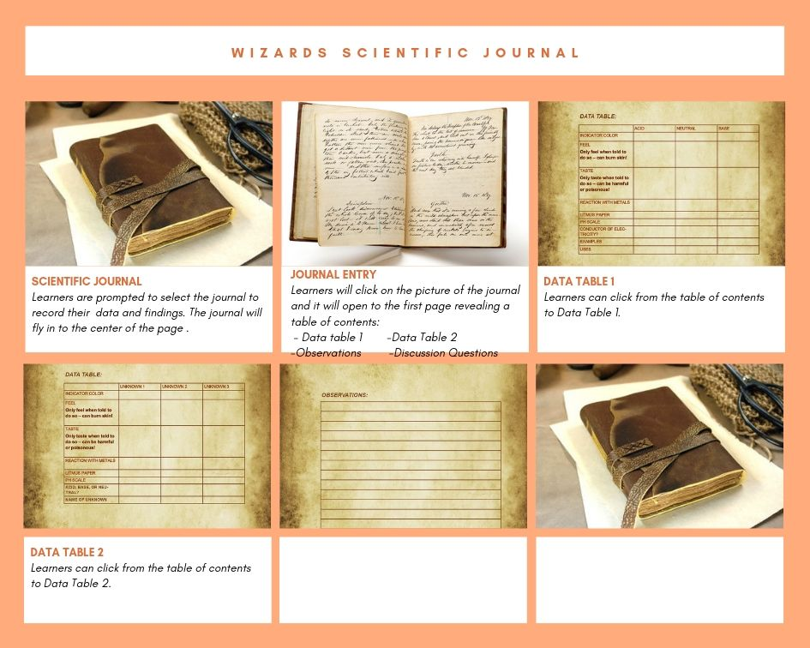

# 6.0 Instructional Treatment Plans

Educators are overworked and underpaid, and oftentimes school districts are reluctant to invest the time and money into new useful resources. This simulation aims to decrease some of that stress by offering an innovative instructional strategy for educators to use that should also please the districts pocketbooks. This scenario-based game should give students an incentive to learn the material, without putting too much of a strain on the teacher. With the current plan to create the simulation on free platforms, districts should not struggle with allowing the simulation to be used.

## 6.1 Game Concept

Set in a fictional world with magic wands and potions, this simulation is simulating a real-life experiment done in chemistry classrooms (Science Buddies, 2012). Students will be able to roleplay as a magic user to create potions, however the science behind the potions is the actual pH scale. By mixing different liquids in with an indicator solution, the student will observe color changes that they have enacted. In a perfect scenario, the entire game will feature customizable avatars, several classroom locations (potions, charms, magical creatures), and all lessons utilizing real world curriculum.

## 6.2 Game Play

The simulation will be using self-directed learning, with Just-in-Time support from an in-game educator (Professor Hufflepot). Students will be selecting and making choices about what actions they take throughout the lesson. Occasional questions will prompt the students to pick from a set of options to test their comprehension as they proceed.

Ideally, the pH chemistry lesson will feature multiple units that will scaffold upon previous units. Some future units would include these lessons and games:

* Deciphering mysterious messages in invisible ink using various pH solutions to solve a mystery in the wizarding world
* Solving a wizard crime by testing various solutions to identify liquids left at the crime scene

# 7.0 Flowchart

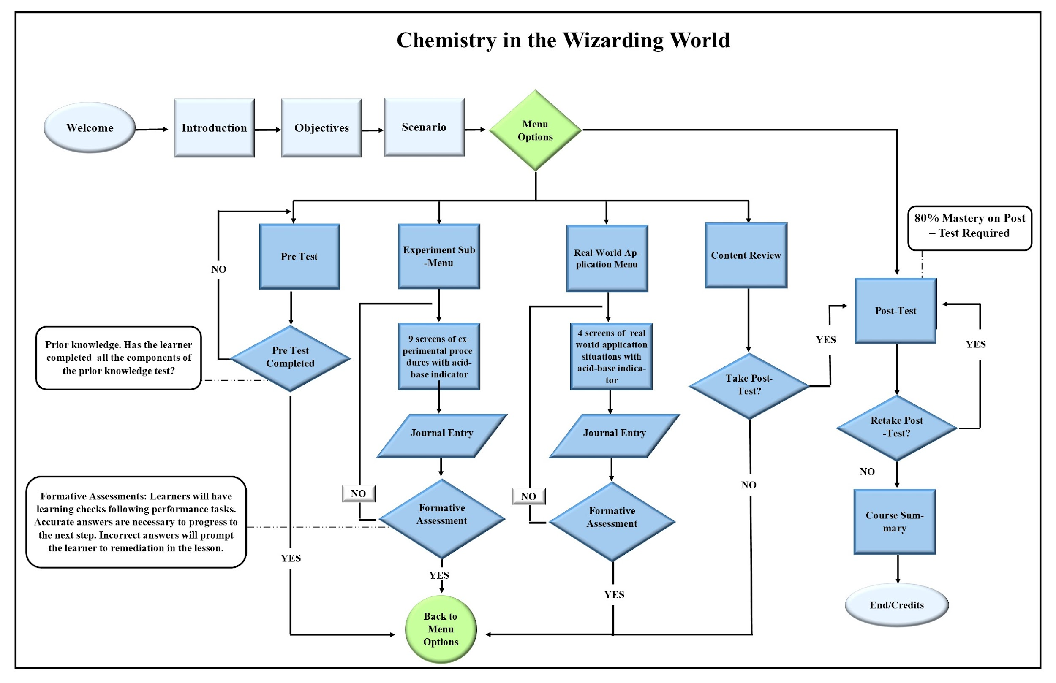

# 

# 8.0 Storyboard

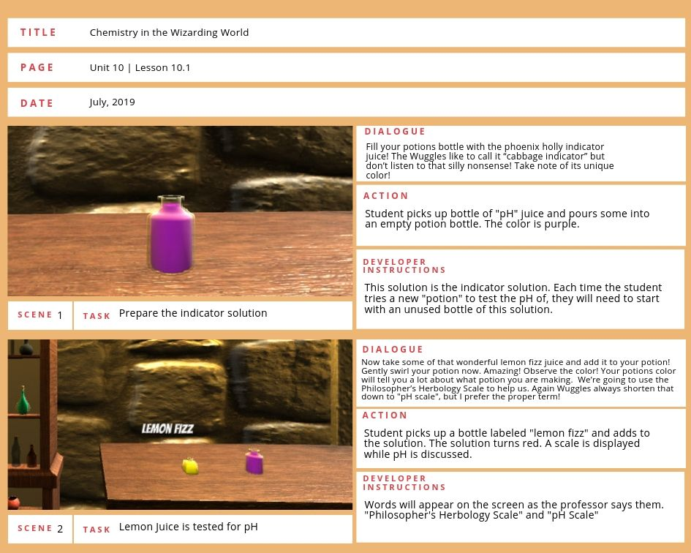

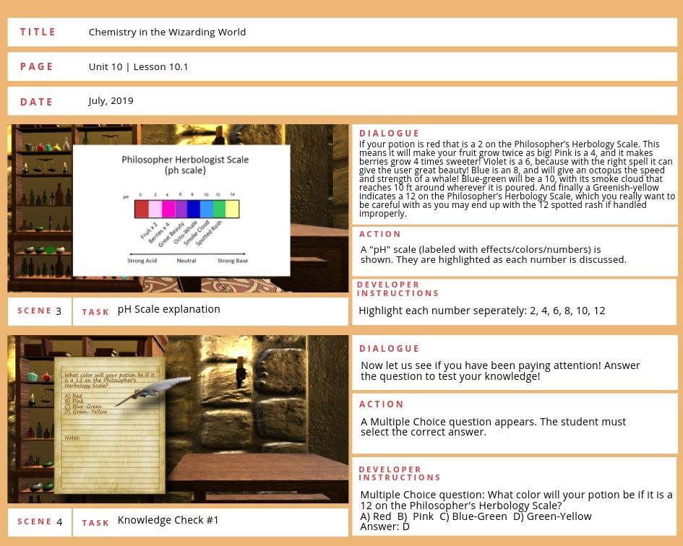

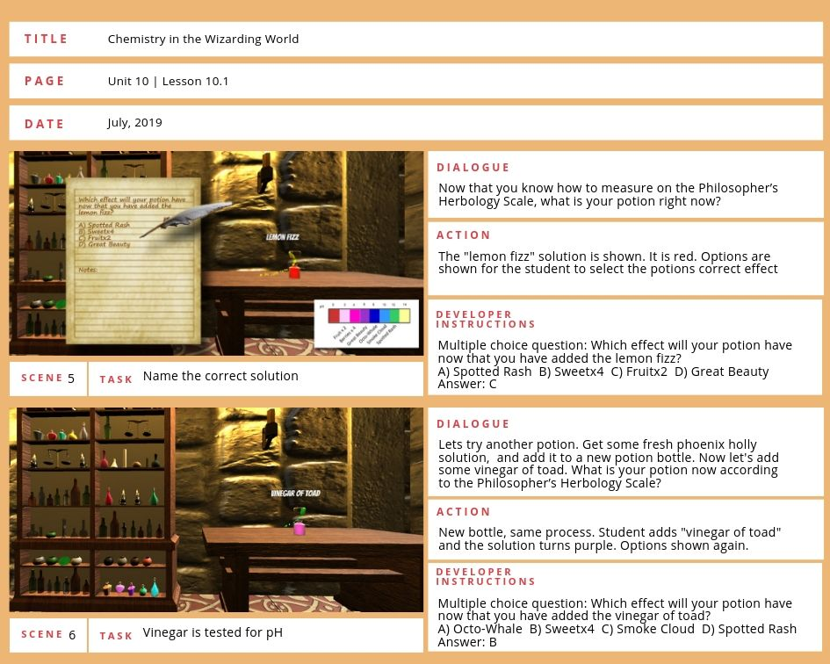

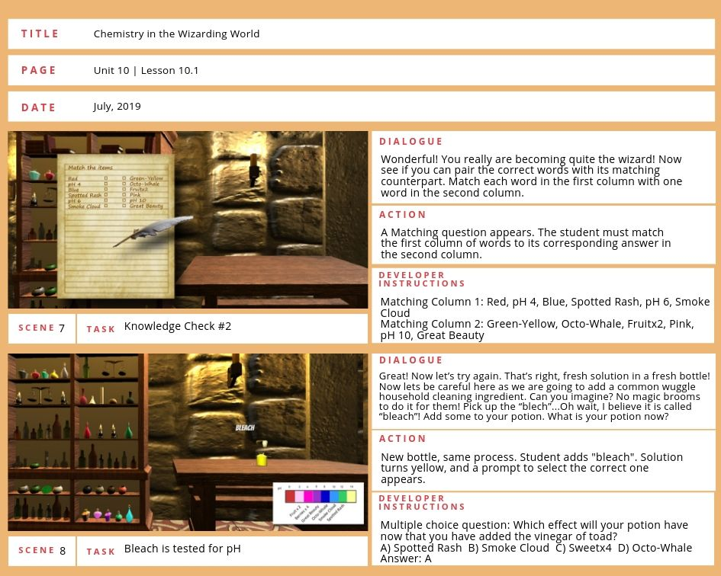

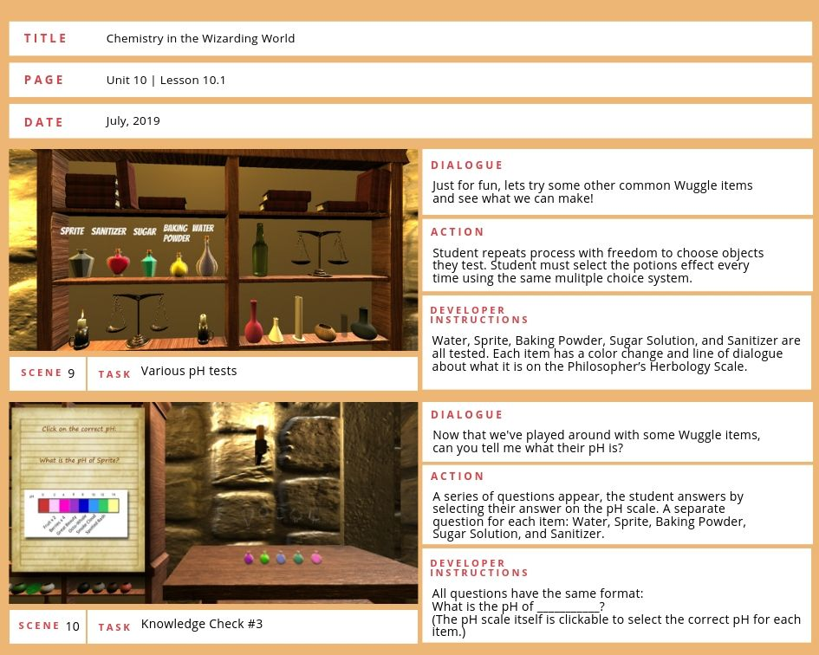

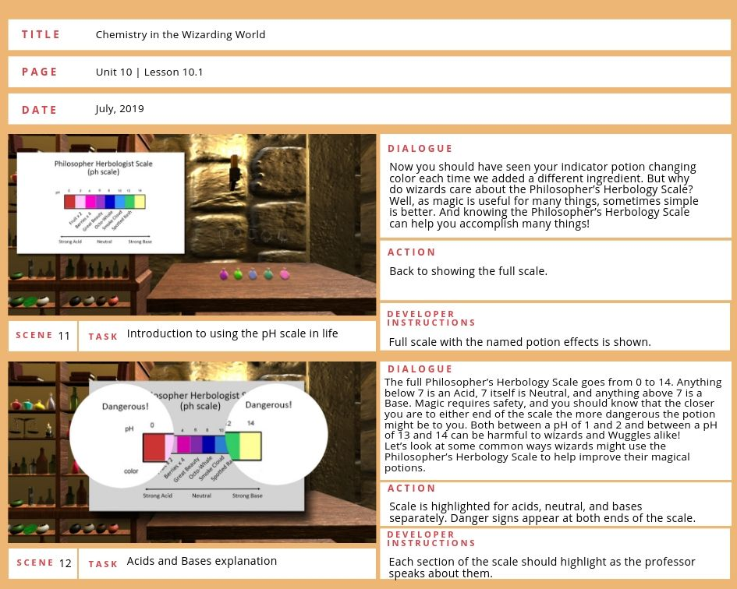

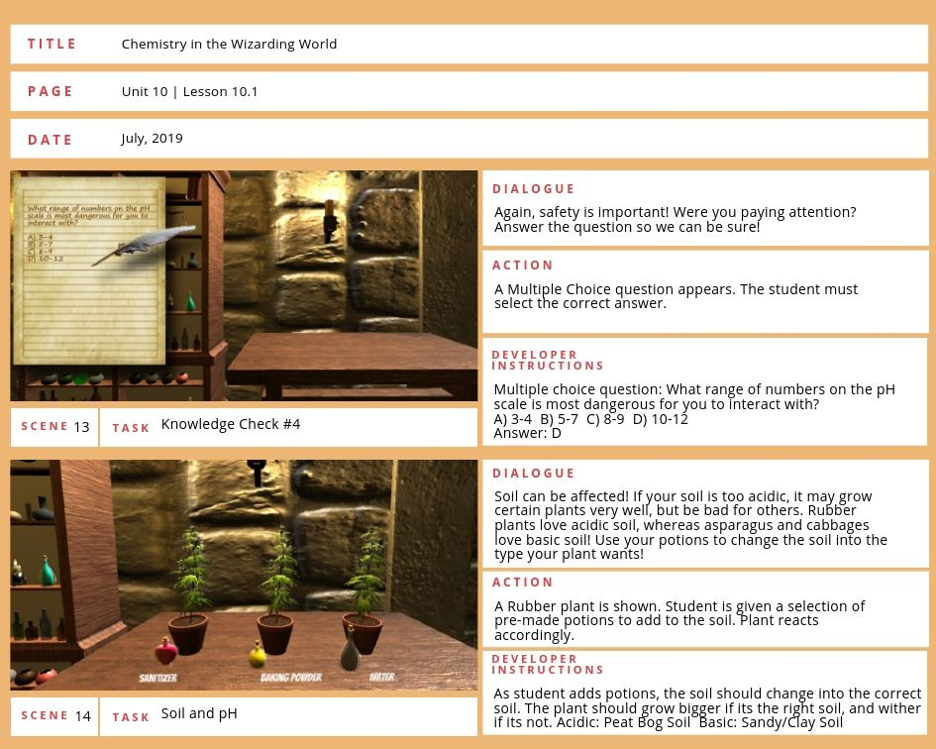

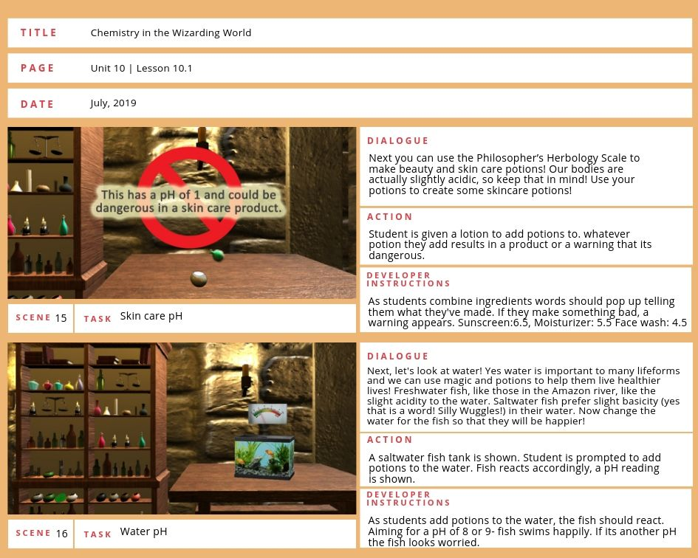

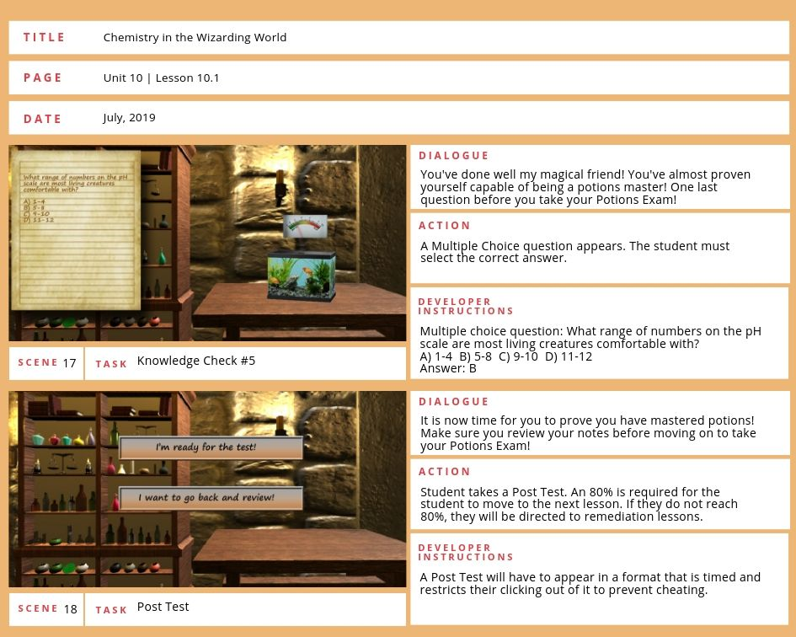

# 9.0 Design and Delivery Standards

The project will be created in Unity and hosted for download by schools, teachers and/or students.

Because this project is being developed as an open resource, there are no delivery constraints being imposed. However, since the project is expected to be used in classrooms where 508-compliance is expected or required, reasonable efforts towards Universal Design for Learning (UDL) will be undertaken. The script will be available as will pre-recorded demonstrations (the prototypes) for students who might not be able to fully navigate a 3D game or virtual reality.

## 9.1 Functionality

The prototype is a video sample of what the process would look like if it was fully interactive. The game currently runs on a first person controller with the animated sequences programmed to run on a timer. What is currently missing from the build would be the activation points so the potions can be “clicked” on to activate, a reset button to reset/refresh the indicator color and/or segments for students to review, the pop-up questions after the student completes each segment, and some sort of tracking of student progress.

## 9.2 Feasibility

To the best of our knowledge, the game can be built as planned given more time. The missing pieces have analogous portions in other games. Many of the bottles used in the demo are part of the 2Ginge Potions with Liquid Simulation (2Ginge, 2018). This package also include activation and reset buttons that could be modified for use in the game (2Ginge, 2017). For the question interface, there is a plugin called MaterialUI that will allow for building and asking questions without having to fully code from scratch (Brackeys, 2016). Finally, the programming for the fish tank and pH meter would be more difficult than the other sequences. There are no prefab fish tanks available in Unity as of this writing. It would have to be built and preferably animated for the fish to move, which is certainly possible but would take some time. The pH meter would have to be programmed with feedback, e.g. as the student adds a potion of certain pH, the meter must adjust from its present level. This would follow the same idea as in other game play where the game keeps track of a player’s health; some items lower the level, some items increase the level, but would involve C# scripting which is beyond the authors’ current abilities.

## 9.3 Recommendations

Once the build is complete, as described above, there needs to be at least one more round of testing with teachers and students to revisit/revise the needs analysis and cognitive task analysis and to determine if any adjustments need to be made. Since the prototype currently lacks interactivity, it was not possible to implement or evaluate its use with the target population.

# 10.0 Appendix

## 10.1 Appendix A - Assessments

***Acid-Base Pre-Test***

1. **Acids taste**
   1. Sweet.
   2. Bitter.
   3. ***sour.***
   4. Salty.
2. **What does the pH scale measure?**
   1. ***the concentrations of acids and bases***
   2. the malleability of a metal
   3. the temperature of the water in a swimming pool
   4. the amount of phosphorus in a compound
3. **Bases feel**
   1. rough.
   2. ***Slippery.***
   3. Moist.
   4. Dry.
4. **Bases react with**
   1. ***acids to produce salts and water.***
   2. water to produce acids and salts.
   3. salts to produce acids and water.
   4. neither acids, salts, nor water.
5. **Which type of solution is one with a pH of 8?**
   1. Acidic
   2. ***basic***
   3. Neutral
6. **Which of the following is true of bases?**
   1. ***The pH is between 8 and 14, has a bitter taste and reacts with metals.***
   2. The pH is between 1 and 6, has a bitter taste and reacts with metals
   3. The pH is between 1 and 6, has a sour taste and reacts with metals
   4. The pH is between 8 and14, has a sour taste and does not react with metals

***Acid – Base Post Assessment***

(Crisanti & Rauf, 2006)

1. **What does the pH scale measure?**
   1. ***the concentrations of acids and bases***
   2. the malleability of a metal
   3. the temperature of the water in a swimming pool
   4. the amount of phosphorus in a compound
2. **Soap is a weak base. What may be generally true about the taste of bases?**
   1. They taste sour.
   2. They taste sweet.
   3. ***They taste bitter.***
   4. They taste salty
3. **If cabbage juice is added to a base what color will it be?**
   1. Pink
   2. ***Green***
   3. Purple
   4. Clear
4. **Which of the following is true of acids?**
   1. The pH is between 1 and 6, has a bitter taste and reacts with metals.
   2. The pH is between 8 and 14, has a bitter taste and reacts with metals
   3. ***The pH is between 1 and 6, has a sour taste and reacts with metals***
   4. The pH is between 1 and 6, has a sour taste and does not react with metals
5. **Lemon juice has a pH of 2. What does this indicate about lemon juice?**
   1. ***It is an acid.***
   2. It is a base.
   3. It is a salt.
   4. It is neutral.
6. **An acid base indicator is a dye that…** 
   1. is always the same color
   2. is colorless
   3. is the same color in both acids and bases
   4. ***is one color in an acid and a different color in a base***
7. **If I add an acid to water the concentration of OH-…** 
   1. Increases
   2. Decreases
   3. ***Stays the same***
   4. Water does not contain OH
8. **A solution with a pH of 11 is…** 
   1. Neutral
   2. Acidic
   3. ***Basic***
   4. Salty
9. **A solution with a pH of 7 is..** 
   1. ***Neutral***
   2. Acidic
   3. Basic
   4. Salty
10. **Bases produce_______when dissolved in water** 
    1. Na+ ions
    2. ***OH- ions***
    3. H+ ions
    4. Cl- ions
11. **A base is defined as** 
    1. A proton donor
    2. A proton
    3. A hydroxide ion
    4. ***A proton acceptor***
12. **Acids produce ______ when dissolved in water** 
    1. Na+ ions
    2. OH- ions
    3. ***H+ ions***
    4. Cl- ions
13. **Bases taste** 
    1. Sweet
    2. Sour
    3. ***Bitter***
    4. Salty
14. **An acid is defined as…** 
    1. ***A proton donor***
    2. A proton
    3. A hydroxide ion
    4. A proton acceptor
15. **Acids taste…**
    1. Sweet
    2. ***Sour***
    3. Bitter
    4. Salty
16. **Bases react with** 
    1. Acids
    2. Metals
    3. Nonmetals
    4. ***Both a and b***
17. **Acids react with…**
    1. Bases
    2. Metals
    3. Nonmetals
    4. ***Both a and b***

***DISCUSSION QUESTIONS:***

(Students record answers to questions with observations and then are discussed in a group)

1. How did your cabbage pH indicator values compare to pH indicator strip values?
2. What other acids and bases do we encounter every day?
3. For what other liquids are you curious about their pH values?

## 10.2 Appendix B - Instruments

**Data Table (In simulation journal)**

Data Table 1:

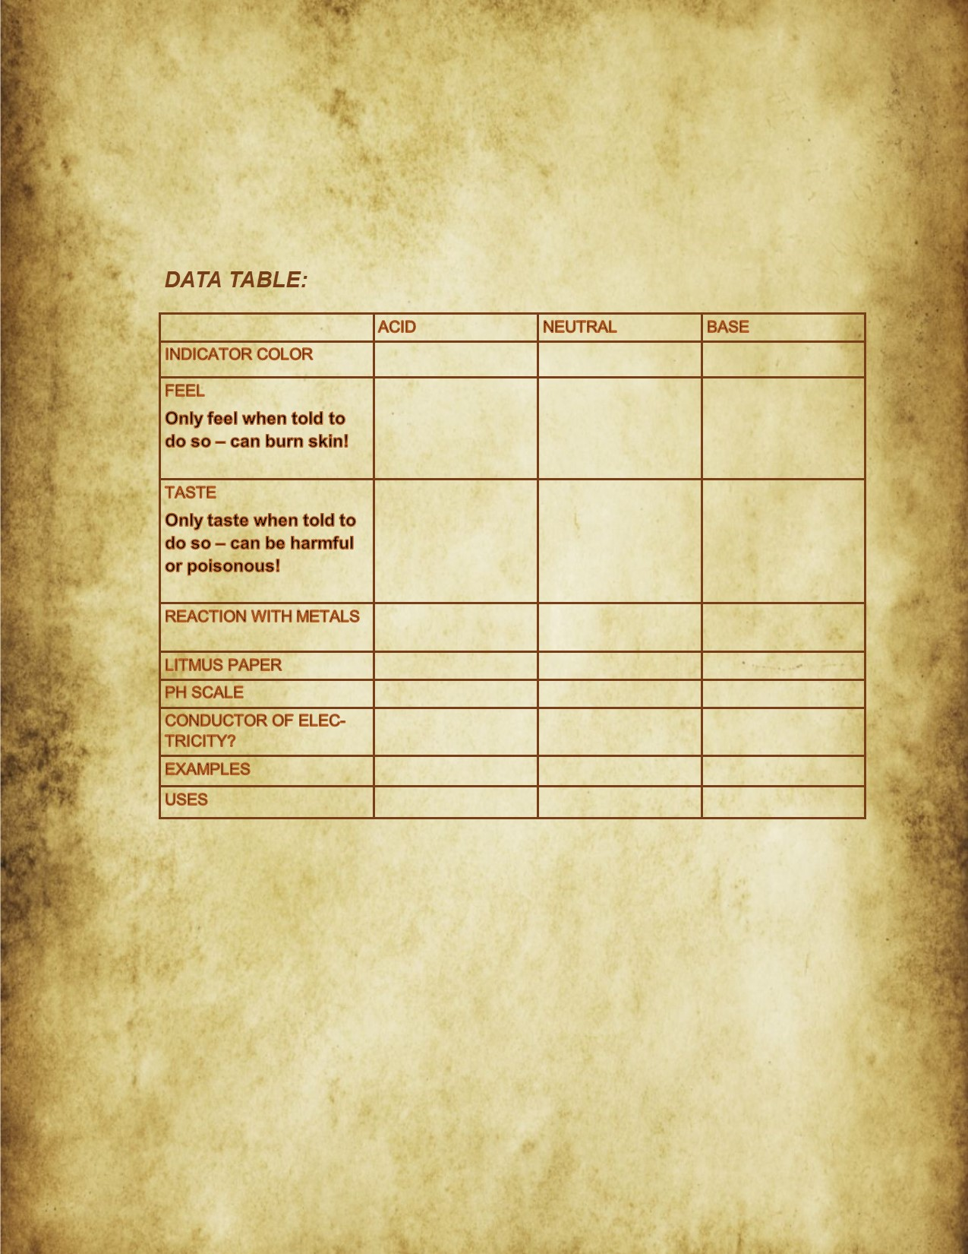

Data Table 2:

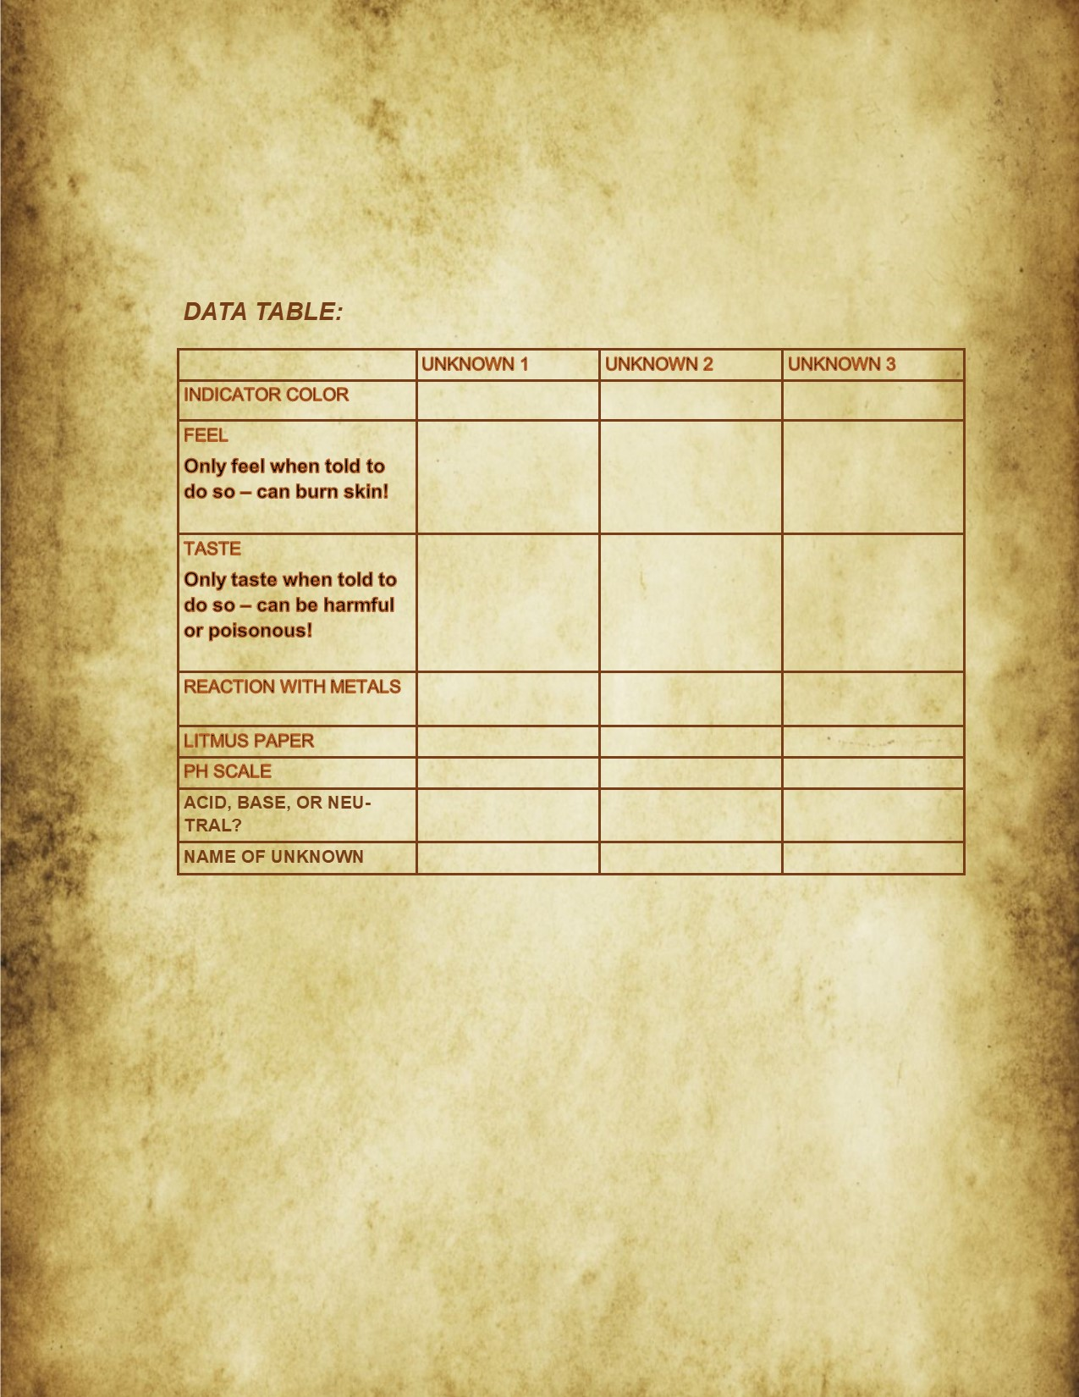

Observation Table:

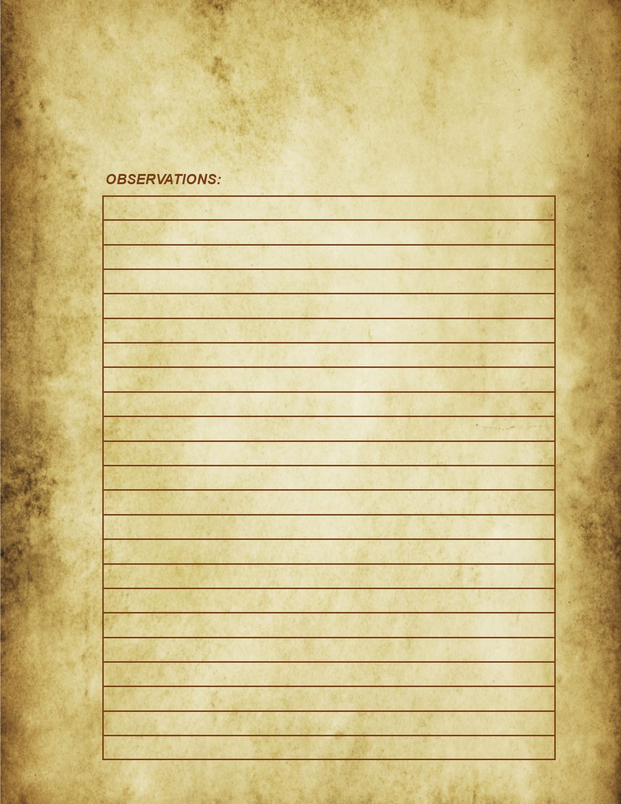

# References

Brackeys. (2016). How to make a Quiz Game in Unity (E01. UI) – Tutorial [video file]. Retrieved from<https://www.youtube.com/watch?v=g_Ff1SPhidg>

Coolican, M. (n.d.). *It's all about that base and acid*. Retrieved from

<http://www.cpalms.org/Public/PreviewResourceLesson/Preview/131166>

Crisanti, G., & Rauf, H. (2006, June 30). *Acid – base chemistry* [PDF]. Farmington: Farmington

Public Schools.

Eyre, P. (2013, July 16). Potions. Retrieved from <https://www.flickr.com/photos/moriartistic/9301278297>

NGSS Lead States. (2013). *Next generation science standards: For states, by states.* Washington, DC: The National Academies Press. Retrieved from https://www.nap.edu

Nkemakolam, O. E., Chinelo, O. F., & Jane, M. C. (2018). Effect of computer simulations on secondary school students’ academic achievement in chemistry in Anambra state. Asian Journal of Education and Training, 4(4), 284–289. Retrieved from <https://doi.org/10.20448/journal.522.2018.44.284.289>

NPR. (2012). Your favorites: 100 best-ever teen novels. Retrieved from <https://www.npr.org/2012/08/07/157795366/your-favorites-100-best-ever-teen-novels>

Pottermore. (2018). 500 million Harry Potter books have now been sold worldwide. Retrieved from <https://www.pottermore.com/news/500-million-harry-potter-books-have-now-been-sold-worldwide>

Prensky, M. (2005). *Teaching digital natives: Partnering for real learning*. Thousand Oaks, CA: Corwin.

Science Buddies. (2012, January 26). Cabbage chemistry--Finding acids and bases. Scientific American. Retrieved from <https://www.scientificamerican.com/article/bring-science-home-cabbage-chemistry/>

2Ginge. (2017). Magic Potions with Liquid Simulation – Tutorial [video file]. Retrieved from <https://www.youtube.com/watch?v=dwqynrQ2OjA>

2Ginge. (2018). Potions with Liquid Simulation [digital file]. Retrieved from<https://assetstore.unity.com/packages/3d/props/potions-with-liquid-simulation-87014>

Unity. (n.d.) VR overview. Retrieved from <https://docs.unity3d.com/540/Documentation/Manual/VROverview.html>